# Interactive star data visualization software

**Li Yunfan, Zhao Yue, Nanshan Muye**

Contact: [16302010002@fudan.edu.cn](mailto:16302010002@fudan.edu.cn)

## Abstract

Non-professionals are often unfamiliar with some of the most common astronomical observations. If you want to know how to easily gain the most basic knowledge and better displayed results, we provide you a simple star display software for non-professionals - "Looking up ". By using the VTK library to achieve the celestial sphere effect, using the BSC and Hipparcos data sets and the matplotlib and VTK tool libraries, coordinate mapping and rendering of stars and 2D stars. Use python's UI framework pyqt5 to achieve control-level linkage. In addition, an exploratory attempt was made to dynamically map the trajectory of the space station.

## Introduction

The night sky of big cities is always full of darkness, but occasionally there are a few stars that remind people that there are other stars outside in space. For those who are unfamiliar with some of the most common astronomical observations, you want to know what stars it is, some mobile apps now already offer users the opportunity to learn about these stars. They can use the mobile phone's own positioning function to locate users. The location, direction, and information about the stars in this sky. The data of these stars include the solar satellites we have widely known, the extraterrestrial stars that have been collected and perfected by astronomers for a long time, and the meteors and satellites of current events. Collecting this data and converting some professional astronomical format data into everyday data formats, we can also create a simple astral database and a star display software for non-professionals.

This year is the 543th anniversary of the birth of Copernicus, and the 473th year of his book "The Operation of Celestial Body". The original name of this book is Latin De revolutuinibus orbium coelestium, in which the word orbium originally means celestial sphere in China. It has been translated into a "celestial body" that we are more acceptable today, but for Copernicus of that era, it was "the celestial sphere." "Tianqiu" is the basic assumption of Greek mathematical astronomy and the product of the ancient Greeks' aesthetic intuition. The Pythagorean school regards the universe as a sphere, the "celestial sphere". The stars are all inside the celestial sphere. The celestial sphere is concentric with the earth (Copernicus thinks it is concentric with the sun), and it is uniform. Rotating motion. In the era of Copernicus, whether the celestial sphere is a physically real object, neither Copernicus nor Ptolemy made a clear statement until Digu Brahe.

The celestial sphere is a model of the celestial sphere, and it is an auxiliary instrument for the popularization of astronomical knowledge. Although people now may have astronomical knowledge, the celestial sphere is a primitive instrument that is basically unscientific. But more than 400 years ago, both the Western world and the Qing Dynasty began to make celestial spheres, instruments for accurate calculation of celestial location at that time.

The "celestial sphere" model is a metaphysical product, but if it is an observer on Earth, the celestial sphere is a very intuitive model. Using the concept and appearance of the celestial sphere as a source of inspiration and reference, we make the astrological data into a 3d movable "celestial sphere" and added functions such as data query.

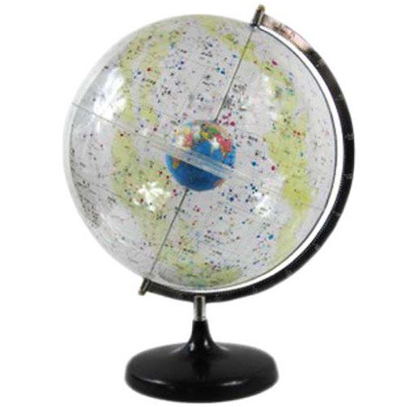

## Basic Astronomical Knowledge And Data Processing

### 2.1 Common Astronomical Coordinate System

#### 2.1.1 Horizontal Coordinate System (A, h)

The first coordinate of the celestial body X: called the horizon longitude or azimuth, is denoted as A.

The second coordinate of the celestial body X: called the horizon latitude or the level of the ground, denoted as h.

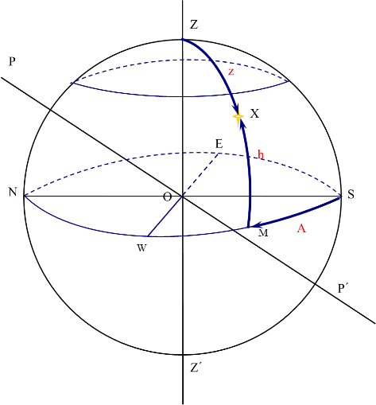

#### 2.1.2 Equatorial Coordinate System (α, δ)

The equatorial coordinate system is also called the second equatorial coordinate system. The equator is taken as the basic circle, and the vernal equinox is chosen as the origin. It does not change with the observation location and time.

The first coordinate of the celestial body X: called the right ascension, is recorded as α.

The second coordinate of the celestial body X: called declination, is denoted as δ.

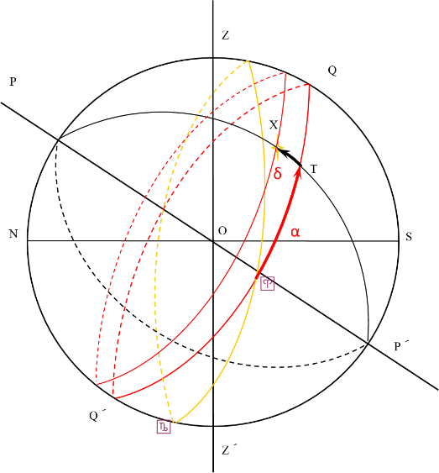

#### 2.1.3 Galactic Coordinate System (L, B)

The celestial coordinate system with the sun as the center and the plane of the Milky Way clearly aligning the stars, its "equator" is the plane of the Milky Way.

It does not change with the location and time of observation.

In 1958, the International Astronomical Union defined the relationship between the galactic coordinate system and the equatorial coordinate system at the Tenth Congress.

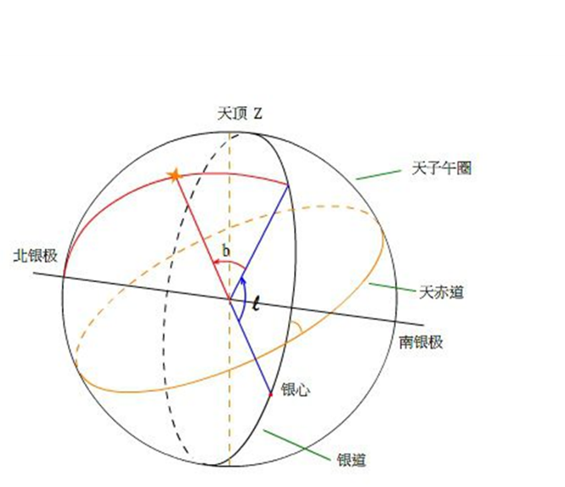

## Data Introduction

### 3.1 Catalogue Of Bright Stars (BSC)

<Http://cdsarc.u-strasbg.fr/viz-bin/cat/V/50>

It gives 9110 highlights at 6.5 bright stars (Ere 2000), stars, B-V, spectral type, self, velocities, and parallax.

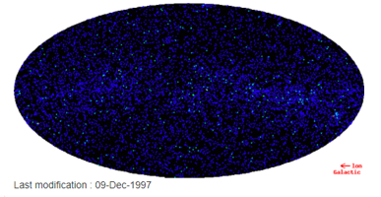

Mainly take the number, common name, coordinates, B-V, Vmag and other data, convert the coordinates into latitude -90 to 90, longitude 0-360 data, delete the vacancy value other than the common name, get 8771 data.

### 3.2 Liba Valley Star Watch (Hipparcos and Tycho)

<http://cdsarc.u-strasbg.fr/viz-bin/cat/I/239>

The main results of the European Space Agency (ESA) Ibaraki Astronomical Satellite (Hipparcos) project. The total number of stars included is 120,313, and the limit is 13 and so on.

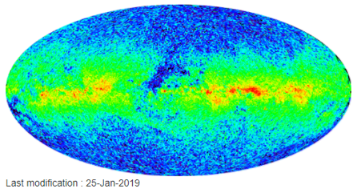

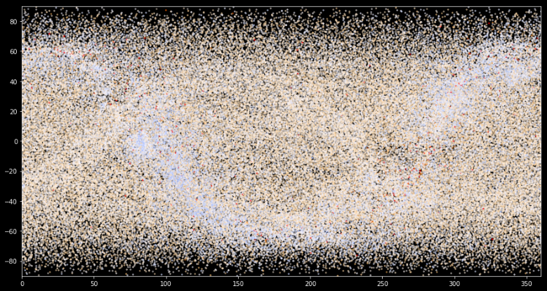

Mainly take the number, coordinates, B-V, Vmag and other data, the coordinates are converted into latitude -90 to 90, longitude 0-360 data. As shown in the above figure, the data volume of the data set is too large, and it takes too long to draw. Therefore, stratified sampling is performed according to the brightness of the star, and the number of stars with a larger Vmag is reduced. A small sample of size 16039 is taken. As a dataset instead of its function.

### 3.3 All-day Constellation Area Data

<Http://cdsarc.u-strasbg.fr/viz-bin/cat/VI/49>

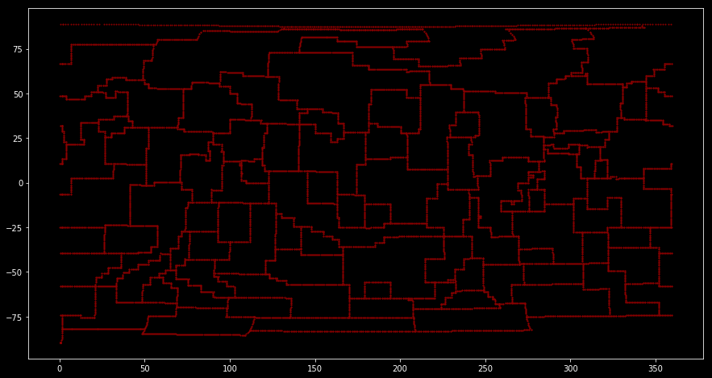

In the above data, the coordinates in the BSC and constellation region data are based on the equatorial coordinate system J2000, and Hipparcos and Tycho are based on the equatorial coordinate system J1991, where the BSC contains the galactic coordinates.

## Data Format Conversion

### 4.1 Vmag

     The full name Visual magnitude refers to the brightness of the star seen by the observer with the naked eye. The size of the star can be negative, the smaller the value, the higher the brightness, and the darker. The apparent magnitude is related to the luminosity (luminosity) of the star and to the distance of the star from the observer. Therefore, a weak or even non-illuminating star can have a very low apparent magnitude, such as a moon at a full moon, etc., and a star with a strong illuminating power often has a high apparent magnitude, etc., because they It is often tens of thousands of light years away from the earth. For example, the absolute magnitude of the sun is only 4.83, but its apparent magnitude is -26.71.

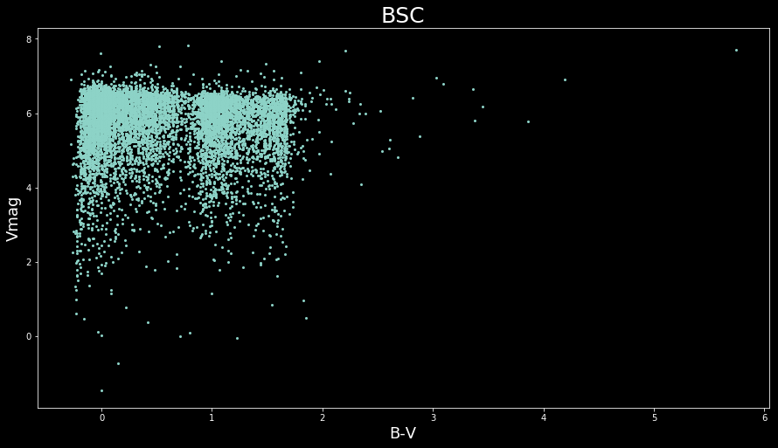

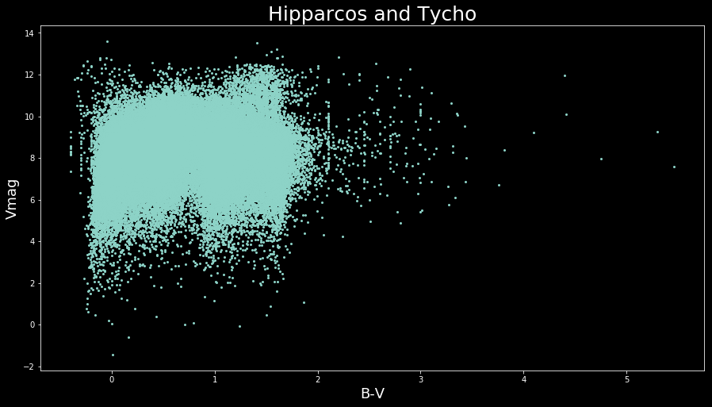

The influence of the apparent magnitude on astronomical observations is very large. According to the observation experience, the smaller the apparent star, the brighter and larger the star appears. As can be seen from the above figure, in the two data sets, the data with Vmag greater than 4 is the majority, and the color is mostly pale yellow. Therefore, when drawing with software, Vmag is an important indicator to measure the size and transparency of the drawn star points. You can get better visual effects in the picture.

### 4.2 B-V color index

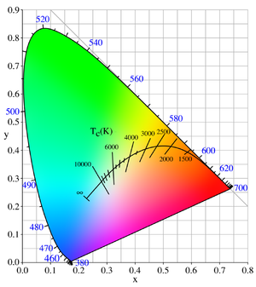

The color index is a scalar quantity used in astronomy to display the surface temperature of a star. To measure this index, the observer needs to use two different filters, U and B or B and V, to measure the luminosity of the target in sequence. This is a very common passband or filter metering system, where B is a filter that is sensitive to blue light and V is a filter that is sensitive to yellow-green visible light. The difference in luminosity measured using different filters is called the color index of U-B or B-V, respectively. The smaller the value, the closer the color of the star is to blue; on the contrary, the larger the color index, the redder the color (or the lower the temperature). This is a series of logarithmic results, where bright celestial bodies present values ​​that are smaller (may be negative) than dim celestial bodies.

The ``BV color index'' is a way of quantifying this using two different filters; one a blue (B) filter that only lets a narrow range of colors or wavelengths through centered on the blue colors, and a ``visual'' (V) filter that only lets the wavelengths close to the green-yellow band through. Hot stars appear bluer than cooler stars. Cooler stars are redder than hotter stars.

While B-V is just a number, we need to convert it to RGB format for easy display on the computer. We use the following formula to write a function to convert the B-V color value to the RGB value:

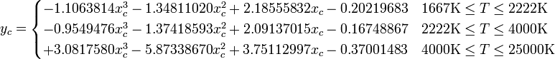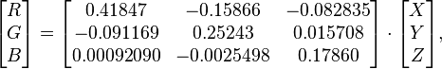

The resulting effect is as follows, which is very obvious on a black background. The larger the B-V value, the larger the star, and the blue, and the yellowish-white-light blue transition.

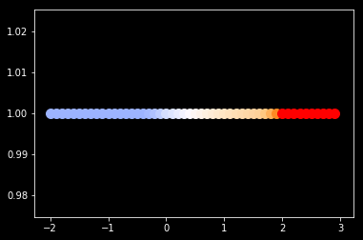

### 4.3 Transformation Of The Astronomical Coordinate System

In the Hipparcos and Tycho dataset, only the stellar based on the latitude and longitude data of the 1991 equatorial coordinate system does not have the more general J2000 (based on the latitude and longitude position of the 2000 equatorial coordinate system) and the galactic coordinate system, so the data needs to be converted. The following is the conversion function of the J2000 equatorial coordinate system and the galactic coordinate system:

The equatorial coordinates of the Northern Silver Pole are in degrees.

Silver center direction corresponding equatorial coordinates

The silver celestial of the northern celestial pole.

If the equator coordinates of the celestial body are then its galactic coordinates (l, b) can be obtained by the following formula: 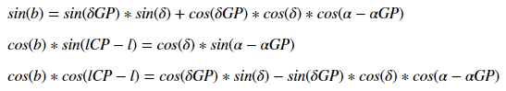

The reverse conversion formula is as follows: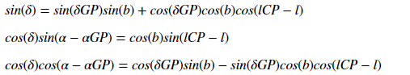

Since the equatorial coordinates of the northern silver pole in the galactic coordinate system of the 1991 structure and the silver ICP of the northern celestial pole were not found, the conversion of the 2000 coordinates was continued, resulting in deviations in the results.

1. Detailed explanation of the galactic coordinate system and the equatorial coordinate system

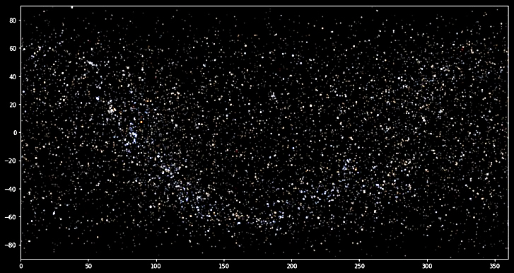

Equatorial

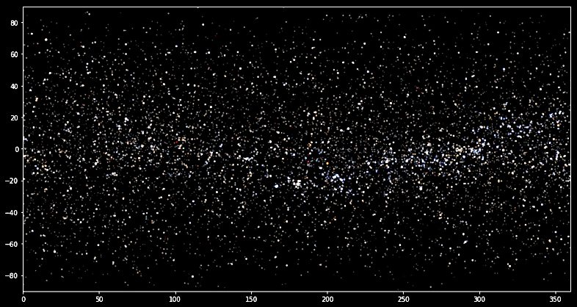

Galactic

Drawing the BSC according to the equatorial coordinate system and the galactic coordinate system, you can find:

1) In the galactic coordinate system, the Milky Way is in the region of latitude and lower, which is very obvious and conforms to the definition of the coordinate system in astronomy.

2) The galactic coordinate system and the equatorial coordinate system are opposite in latitude. It can be seen that in the equatorial coordinate system, the brighter area in the Milky Way is less than 180 degrees, and in the galactic coordinate system is greater than 180. Degree of place. Therefore, as a different coordinate system for the two reference systems, they have the opposite meaning in the map. The equatorial coordinate system is suitable for viewing from the outside of the sphere to the spherical surface, and the galactic coordinate system is suitable for viewing inside the sphere from inside the sphere. Therefore, the equatorial coordinate system can be directly used to draw the celestial sphere, and the galactic coordinate system can be directly used to draw a visual map looking up at the starry sky. If you want to use the other side, you need to do the conversion on the latitude coordinates.

More about BSC

Based on the equatorial coordinate system and the galactic coordinate system data in the BSC, the position of the star in the coordinate system is plotted, the B-V is converted into RGB data, and the transparency is changed according to the Vmag size.

## Our Visualization Attempt

We hope to have a good visual display effect on the stars of the sky by designing an interactive interface. So we want to render the stars from 3D and 2D respectively. The technology we use in 3D is VTK. The technology used in 2D is matplotlib. .

The 3D part is implemented with VTK, showing a starry sky effect from the earth, mapped to the outer spherical shell. When the mouse clicks on the non-spherical center, there is a sphere-rotating effect, and the mouse wheel can zoom in (near) to reduce (away from) the effect.

We also do a coloring function for the 3D part. Users can choose different colors to render the star shell and background color according to their preferences. See the user manual for details.

The 2D part has two interfaces, one is the small picture preview effect on the main interface, and the other is the full screen preview effect, which is triggered by the full screen button of the main interface. The 2D part uses matplotlib's scatterplot function to render each star with parameters. Since the dynamic drawing time is long and the data set is static, we select the preset parameters and save the rendering effect. Only the finished image is displayed in the program.

On both 2D map interfaces, there are checkboxes for switching between the equatorial coordinate system and the Galaxy coordinate system view. There are also options for whether or not there is a visible coordinate axis. There is also a function on the 2D full-screen interface. The mouse clicks on any position on the star map to return. Its neighboring star. The interactive effect is reflected in the fact that two text boxes can be dynamically triggered with the click event to display the corresponding click coordinates and the returned star information.

In addition, the main interface also has the function of inputting the star body number to return the star body information, and the effect is similar, and will not be described.

The user can select either of the BSC and Hipparcos data sets for rendering, but the effect is similar but not the same.

Users can also select stars that can be visually mapped to stars according to stars, etc. The linkage effect is reflected in both 3D and 2D images.

## Looking towards furthermore

### 6.1 Get the celestial FITS data file

The celestial FITS data managed by NASA contains a number of celestial indicators. You can use python to read the FITS file to parse the contents. In this project, since the complete downloadable FITS data set is not found, it is in a single celestial body. There are some defects in the image. The University of Groningen in the Netherlands has written Kapeteyn, a library for analyzing celestial data in Python, and many other astronomers and computer scientists have started writing python libraries to satisfy more specialized astronomical studies, using functions such as data analysis and various astronomical indicators. Image display. The following figure shows an example of image display using the FIDS data of the M101 Nebula in the Kapeteyn manual. If we can get a relatively complete FITS data set and join the project, our "Astronomical Museum" can be more perfect and more professional.

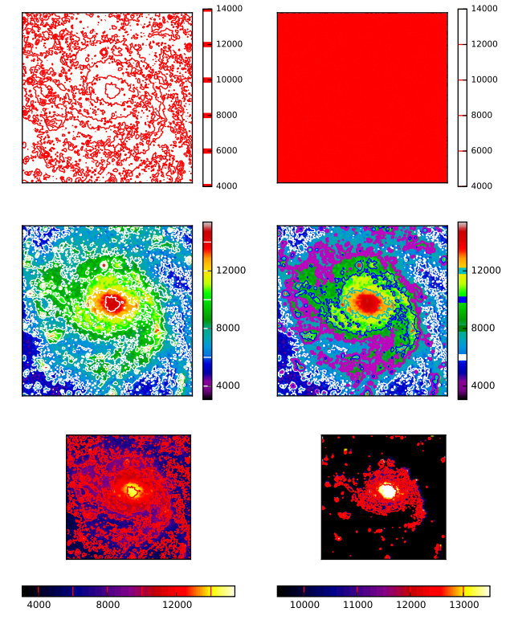

### 6.2 Get the motion data of the star

Today's various planetarium software can simulate people's observation behavior, and can provide the orientation of each person's celestial body at a certain place, at a certain time, or at an altitude, that is, the apparent position of the celestial body. Calculating the visual position requires not only the relative coordinates of the celestial body (the equatorial coordinate system or the coordinates of the galactic coordinate system), but also the celestial body's own speed (unit: angular second / Julian century), parallax (unit: angular second), visual direction Astronomical data such as speed (in kilometers per second), which is mostly not found in the free data set provided by VizieR. Since the calculation formula for this aspect has been obtained by astronomers, if we can get the various parameters needed to calculate the visual position, we can provide more real-time information in the software, close to the observation habits of astronomy enthusiasts.

Previously we were visualizing data from stars outside the solar system, as well as planets and satellites and many satellites in the solar system. The geographic location data of the satellite can be obtained from current events, so we use current events data to simulate the orbit of the satellite.

## The Real-Time Trajectory Visualization Of The Space Station

Use matplotlib, basemap two basic libraries and skyfield to visualize the real-time trajectory data of the space station. Visualization with orange and white indicating high-low

**File directory structure:**

* Satellite_visualization.py Animation of space station moving
* Satellite_visualization2.py Same as above, just changed some settings
* Skyfield_draw_orbits2.py draws orbital models of several satellites
* Skyfield_draw_circles.py basemap draws the projection of the satellite orbit

**Use a live dataset downloaded from the network:**

* De421.bsp
* Deltat.data
* Deltat.preds
* Full_Catalog-20190613T0000.tle
* Leap_Second.dat
* Stations.txt

The basic effects are as follows:

## Division of Labor

Li Yunfan: Design and implement interactive user interface, software testing, report rounding up, software user manual and tutorial

Nanshan Muye: real-time data acquisition of satellite and orbital space stations, visualization of space trajectories based on real-time data

Zhao Yue: Proposed the idea of celestial sphere. 3D and 2D visualization realization.

## Refernces

[1]刘佳成. 新天文参考系若干问题的研究[D].南京大学,2012.

[2]刘次沅.再论银道坐标系的定义[J].陕西天文台台刊,1990(01):26-29.

[3]金文敬.天体测量星表与巡天观测的进展[J].天文学进展,2009,27(03):247-269.

[4]张捍卫, 许厚泽, 王爱生. 天球参考系与地球参考系之间的坐标转换研究进展[J]. 测绘科学, 2005, 30(5):105-109.

[5]刘林, 汤靖师. 地球卫星运动中坐标系附加摄动与参考系选择问题[J]. 空间科学学报, 2008, 28(2):164-168.

[6]凌兆芬, 萧耐园. 依巴谷星表和第谷星表的特征和意义[J]. 天文学进展, 1999(1):25-32.

[7]金文敬, 李东明, 唐正宏, et al. 未来的国际天球参考架[C]// 新世纪天文发展方向研讨暨中国天文学会第二届学术大会. 2003.

[8] University of Groningen. Kapteyn Package [DB OL]. http://www.astro.rug.nl/software/kapteyn/, 2015,03,13